Web App for Containers Code Sample

# Component List

This table lists all the Azure components used in the code sample and describes what they are used for.

|  |  |
| --- | --- |
| **Type** | **Description** |
|
| Web App for Containers | The Developer Finder web application which has a Python backend and AngularJS frontend. |
| The Chat backend system that provides the chat capabilities in the Developer Finder web application. This has a Ruby backend and no frontend. |
| MySQL database | Database the web application interacts with. |
| PostgreSQL | Database the Ruby Chat app interacts with. |
| Azure Container Registry | The container registry where the Docker images are stored. |
| Logic App | Sends SMS messages when a chat is initiated between two users. |
| Function App | Logs custom events to Application Insights. |
| Application Insights | Stores custom events used for debugging and monitoring app status. |
|  |

# Function App

This section illustrates the Function App used in the code sample.

## web-app-on-linux-function

This Function app logs custom events to Application Insights. It is called by Python back end code, Angular JavaScript, Logic Apps, and other Function Apps. See the **Src\Diagrams.vsdx** Visio diagram to see where it fits into the entire process.

# Logic App

This section illustrates the Logic App used in the code sample.

## send-sms

This Logic App sends SMS messages when a chat is initiated between two users. See the **Src\Diagrams.vsdx** Visio diagram to see where it fits into the entire process.

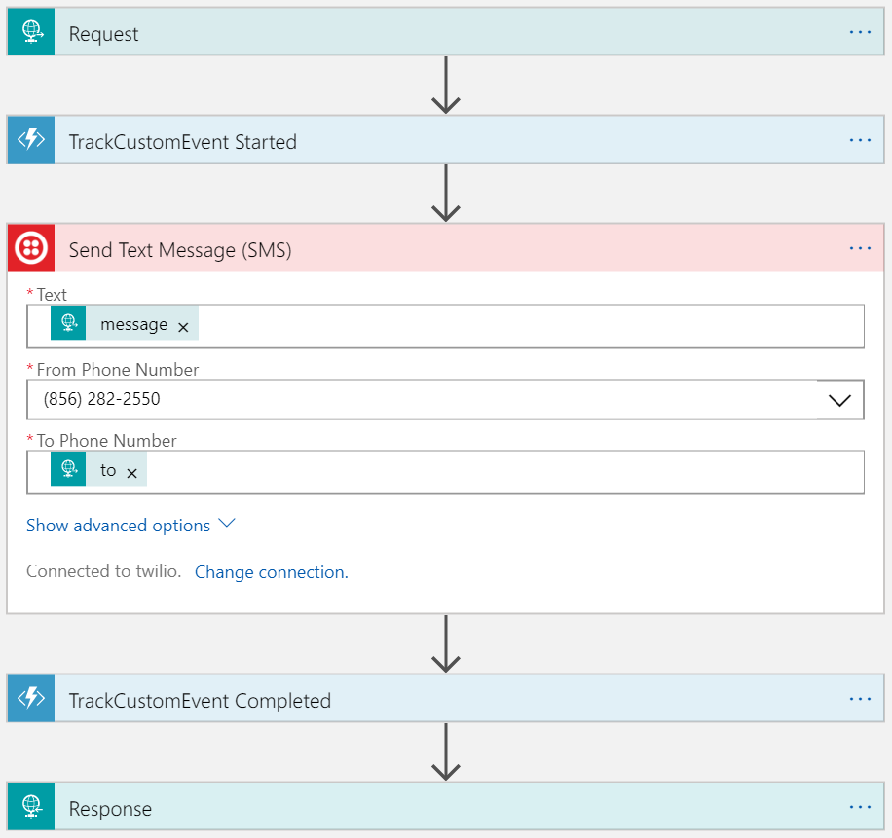

# Application Insights Status Logging Matrix

This table describes all of the Custom Events and their associated metrics that are logged to Application Insights.

|  |  |  |  |  |  |
| --- | --- | --- | --- | --- | --- |
| Log Type | Log Name  (Event Name in Application Insights) | Metric | Host | Triggers/Events | Logged Content  <<description>> placeholder is the text in the Trigger/Event Column. |
| Status Log | Python Web App Status | Python Web App | Web Server Host Name | **All API calls use this format:**  <[Python App or Ruby Chat]> REST API invoked - <Name of API method invoked>  **All Azure Functions use this format:**  Azure Function <Function Name> Invoked  **All Logic Apps use this format:**  Logic App <Logic App Name> Invoked | DESCRIPTION is the value from the Triggers/Events column that corresponds to the item being logged.  <<Date and Time Stamp (in milliseconds)>> --  <<DESCRIPTION>> --  Status: <<[Success/Failure]>> |
| Status Log | Python REST API Status | Python REST API | Web Server Host Name |
| Status Log | Logic App Status | Logic App |  | <Logic App Name> Started  <DESCRIBE EACH EVENT IN THE LOGIC APP>  <Logic App Name> Completed | <<Date and Time Stamp (in milliseconds)>> --  <<Logic App Step Name>> --  <<DESCRIPTION>> --  Status: <<[Success/Failure]>> |